EC2 INSTANCE CHALLENGE'S

1. Launch one EC2 instance using Amazon Linux 2.
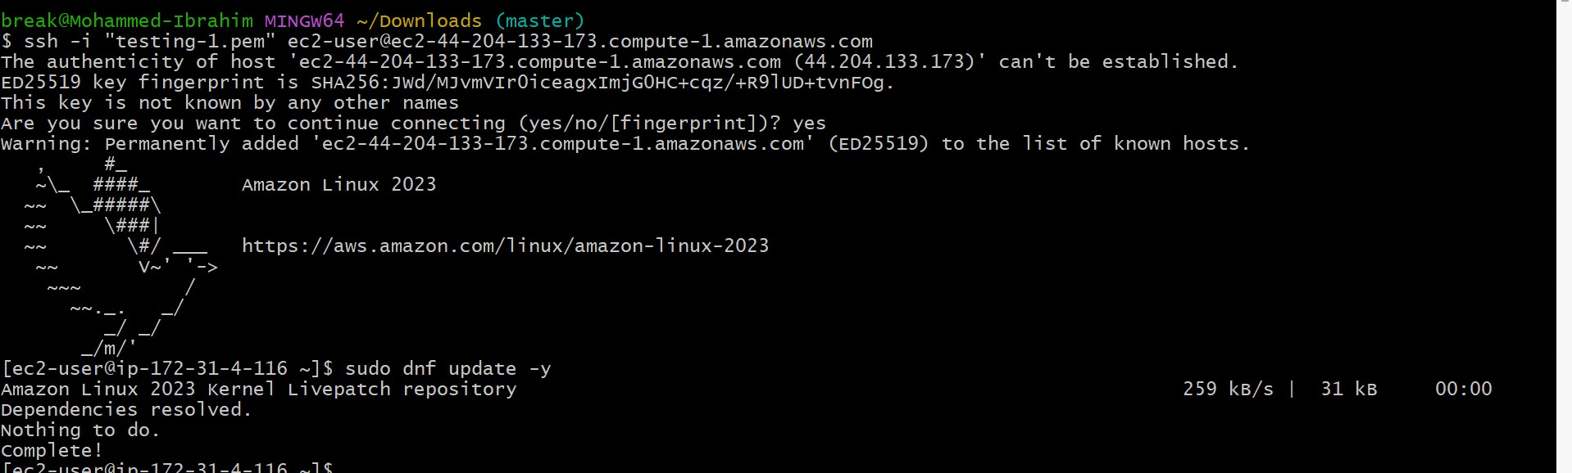

2. Install Docker.
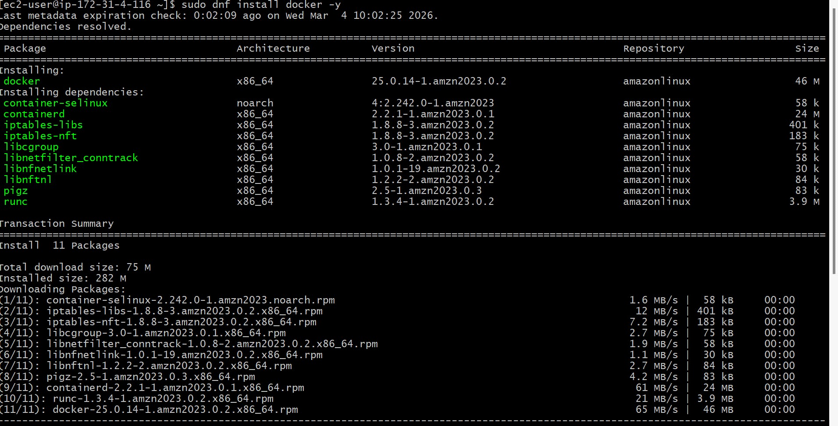

3. Install Jenkins.
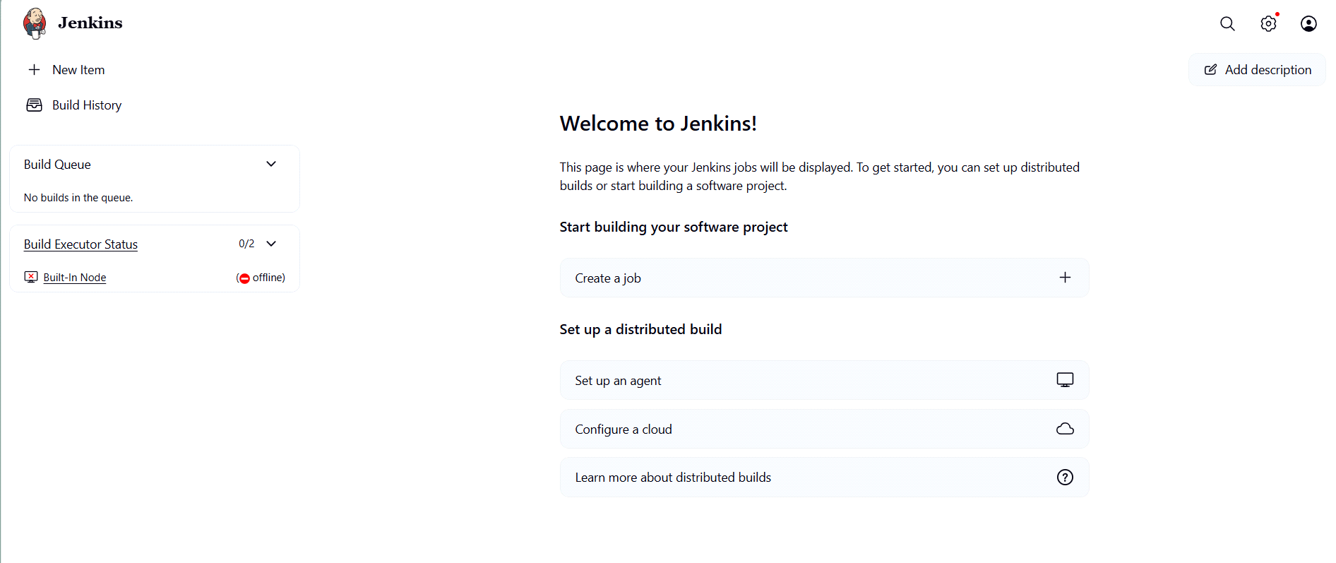

4. Install Apache.


5. Install Nginx.
